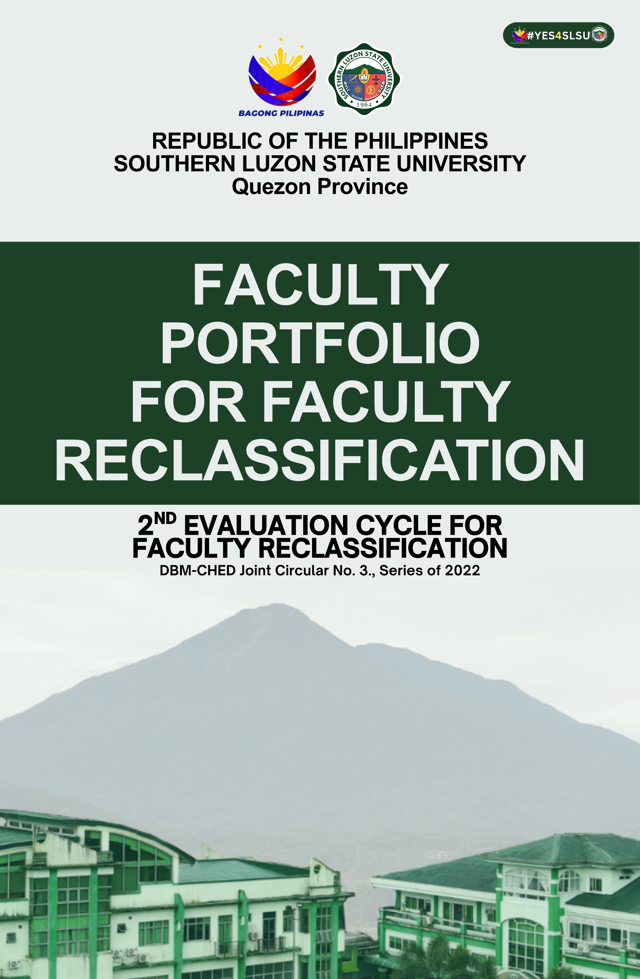

RENATO R. MAALIW III
PROFESSOR I
COLLEGE OF ENGINEERING
Covered Period: August 1, 2023 – July 31, 2026
Second Application
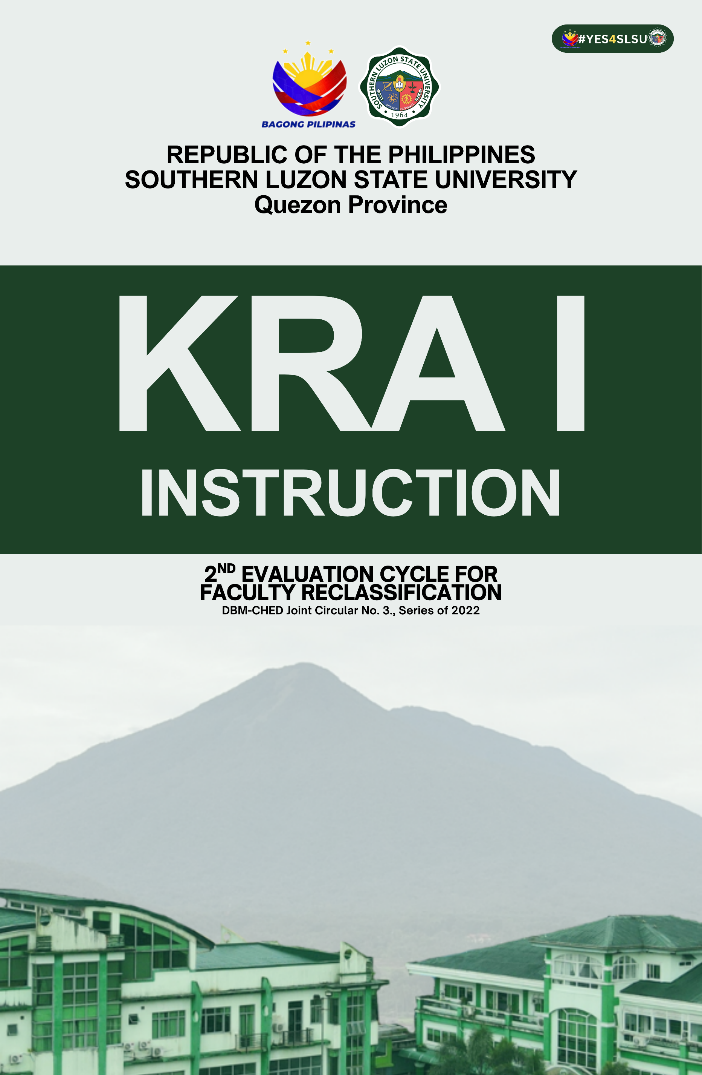
RENATO R. MAALIW III
PROFESSOR I
COLLEGE OF ENGINEERING
Covered Period: August 1, 2023 – July 31, 2026
Second Application
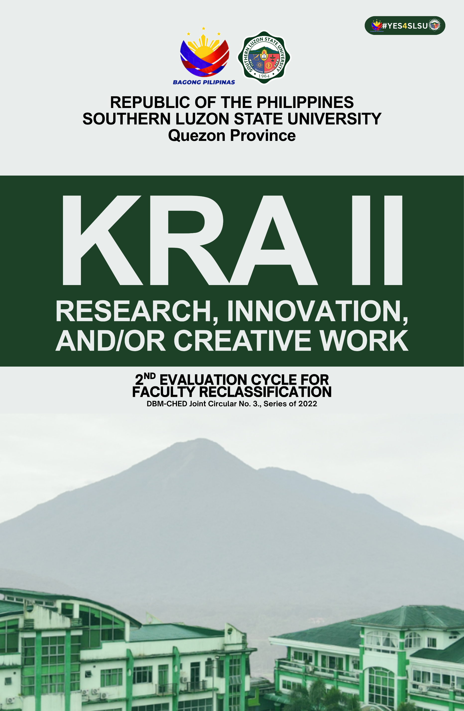
RENATO R. MAALIW III
PROFESSOR I
COLLEGE OF ENGINEERING
Covered Period: August 1, 2023 – July 31, 2026
Second Application
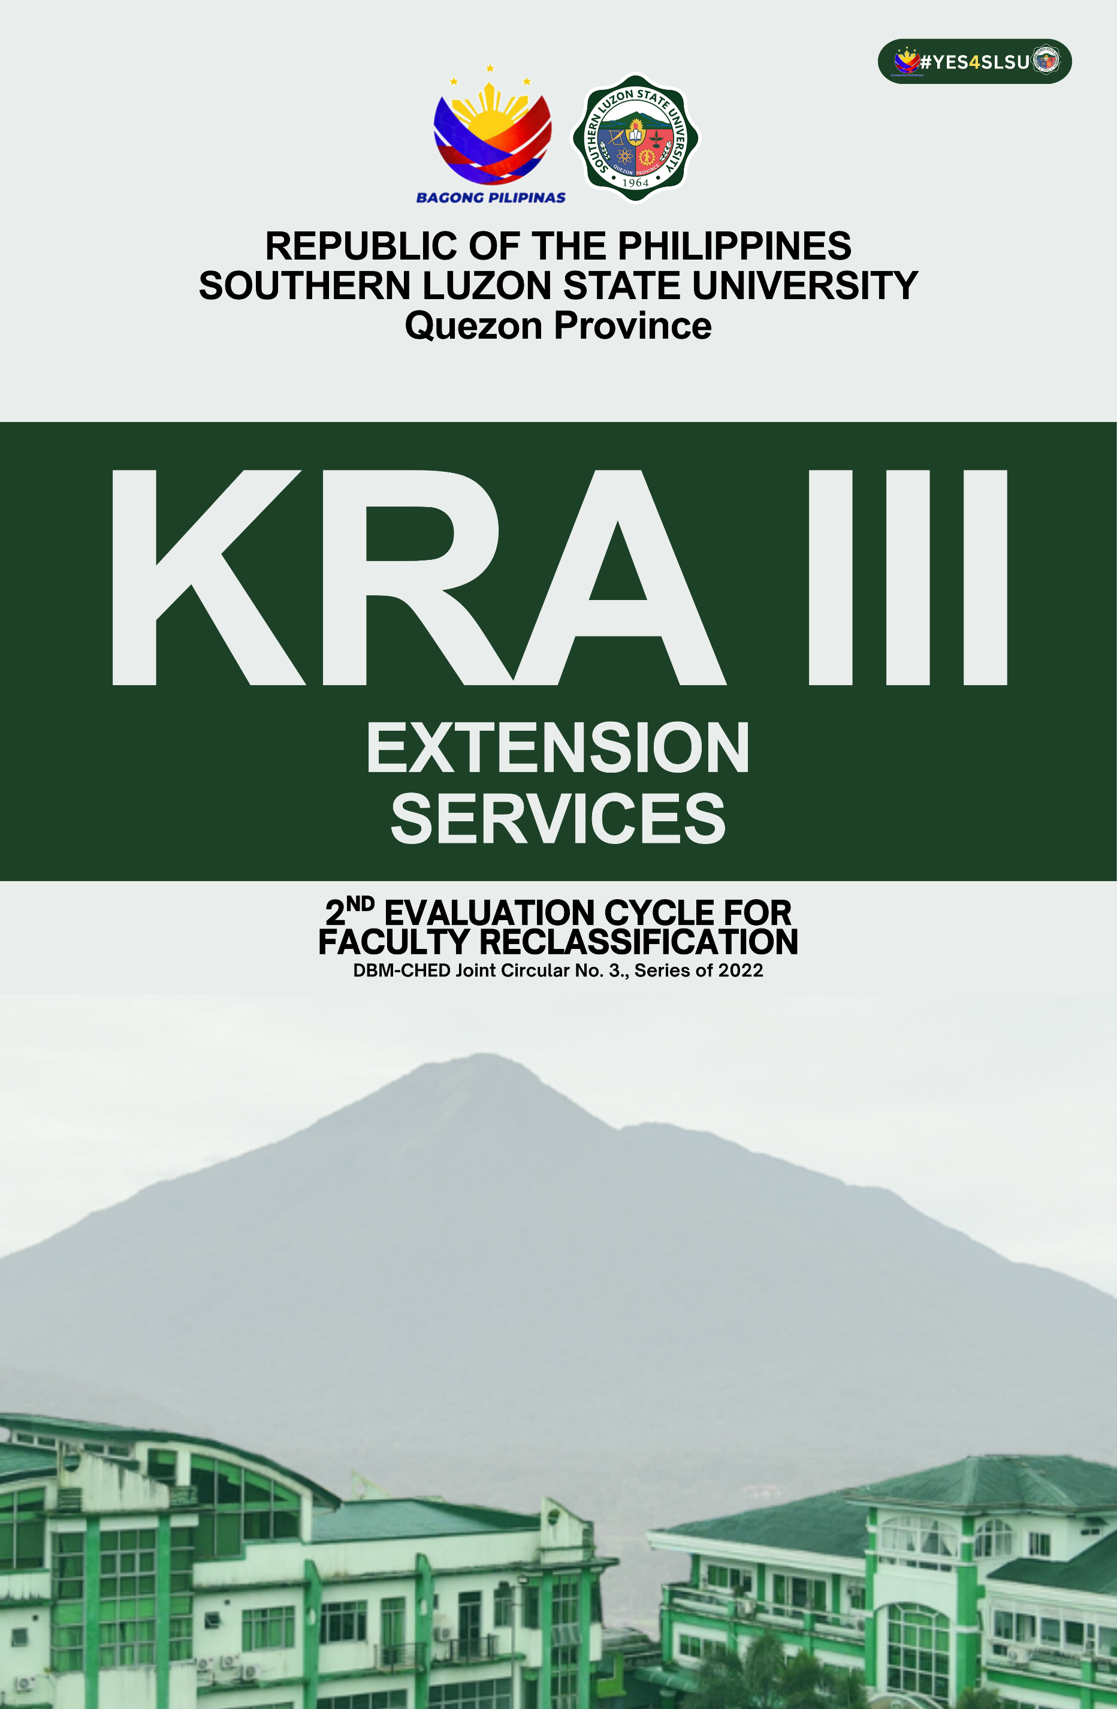
RENATO R. MAALIW III
PROFESSOR I
COLLEGE OF ENGINEERING
Covered Period: August 1, 2023 – July 31, 2026
Second Application
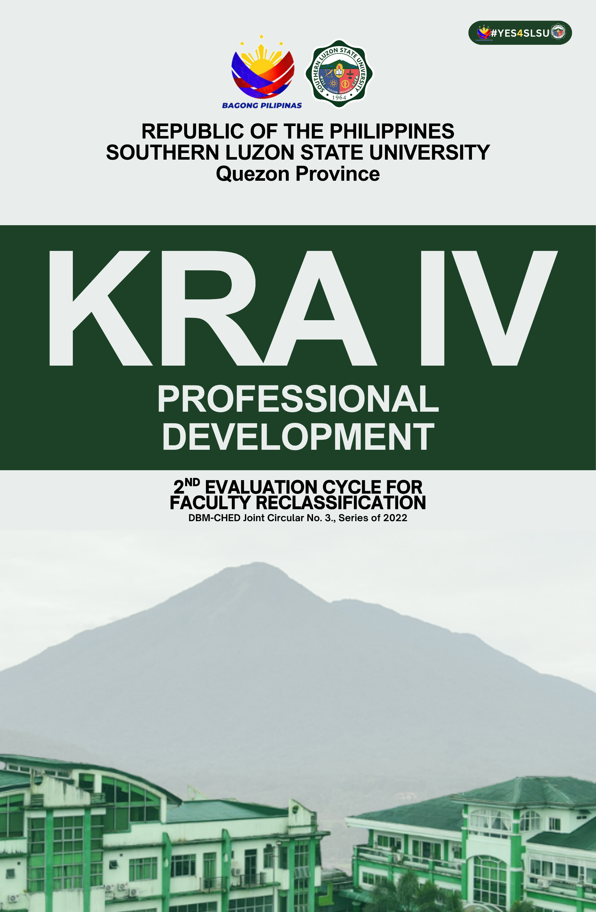
RENATO R. MAALIW III
PROFESSOR I
COLLEGE OF ENGINEERING
Covered Period: August 1, 2023 – July 31, 2026
Second Application

